Customer

|  |  |  |  |  |  |  |  |  |
| --- | --- | --- | --- | --- | --- | --- | --- | --- |
| **Customer ID** | Customer First Name | Customer Last Name | Customer Street Address | Customer City | Customer State | Customer Zip Code | Customer Phone Number | Customer Email |



Transaction

|  |  |  |  |  |
| --- | --- | --- | --- | --- |
| **Transaction ID** | Transaction Amount | Transaction Date | *Customer ID* | *Employee ID* |



Employee



|  |  |  |  |  |  |  |  |  |  |
| --- | --- | --- | --- | --- | --- | --- | --- | --- | --- |
| **Employee ID** | Employee First Name | Employee Last Name | Employee Street Address | Employee City | Employee State | Employee Zip Code | Employee Date Employed | *Store ID* | *Department ID* |



Store



|  |  |  |  |  |  |  |
| --- | --- | --- | --- | --- | --- | --- |
| **Store ID** | Store Street Address | Store City | Store State | Store Zip Code | Store Manager First Name | Store Manager Last Name |



Department



|  |  |  |  |
| --- | --- | --- | --- |
| **Department ID** | Department Type | Department Manager First Name | Department Manager Last Name |

Product



|  |  |  |  |  |  |
| --- | --- | --- | --- | --- | --- |
| **Product ID** | Product Type | Product Price | Product Weight | Product Quantity | Product Brand |



Contains



|  |  |  |
| --- | --- | --- |
| **Transaction ID** | **Product ID** | Quantity |

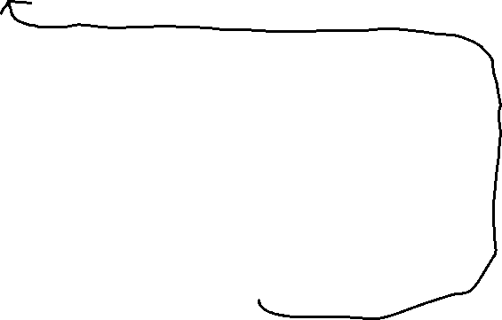

Store Product

|  |  |
| --- | --- |
| **Product ID** | **Store ID** |



Store Department



|  |  |
| --- | --- |
| **Store ID** | **Department ID** |

*For the transaction quantity attribute, I changed it back to transaction amount. The amount is for how much a customer owes after making one or many transactions.

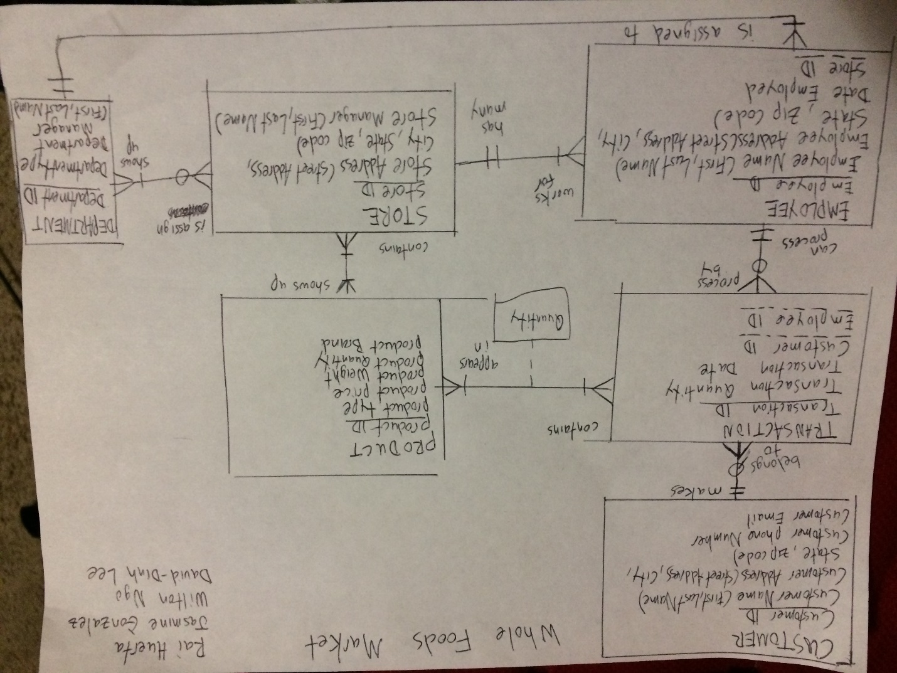

The organization we chose for this model is Whole Foods Market, a natural-foods supermarket chain. Whole Foods has 500 stores in the North America and 7 in the UK, with many more stores in development across the US. The company employs roughly 95,000 people.